**DATA SCIENCE SKILL-1**

1. INTRODUCTION TO PANDAS
2. Include .csv file in python

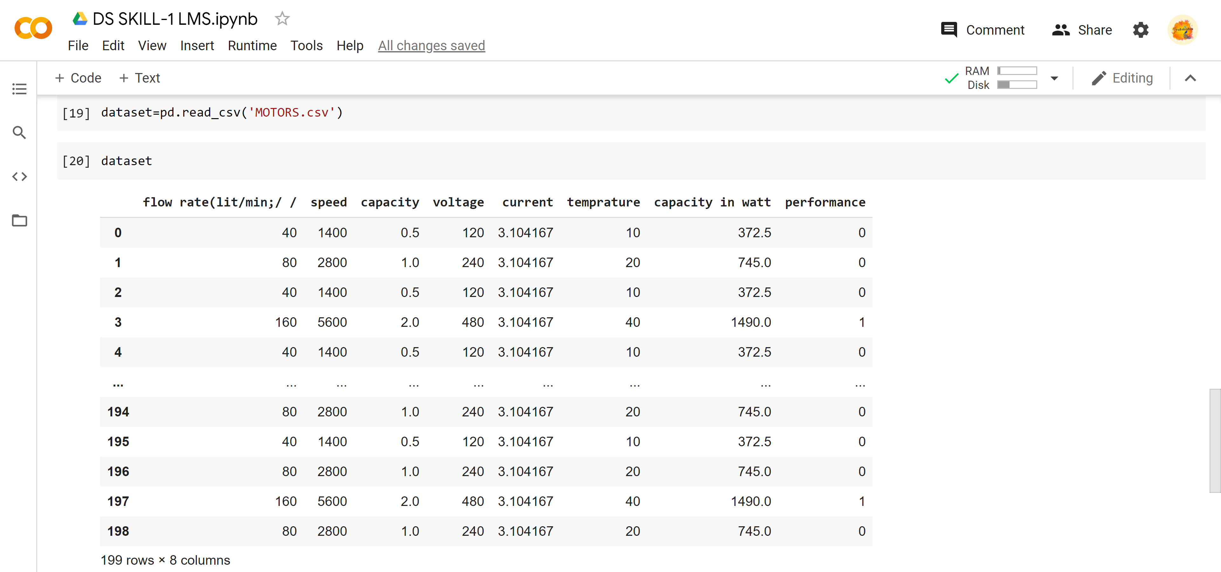

* 1. Use series method to convert the following list [‘a’,’b’,’c’,’d’]

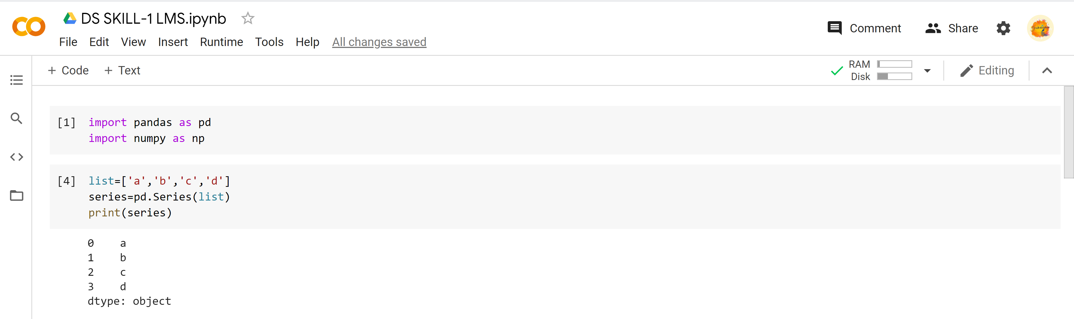

* 2. Given the lists which contain names of students and their scored marks you have to create data frames which club them all using pandas. student list is [' Name 1' ,' Name 2', ' Name 3' ,' Name 4', ' Name 5' ' Name 6'] and you are given a 2d matrix which contain their marks. Their marks are [[67,89,68,95], [87,94,97,76], [77,85,99,74], [90,89,92,78], [83,97,80,98],[90,90,80,87]] and subjects list containing ['DS','AI','MPII', 'CNS']

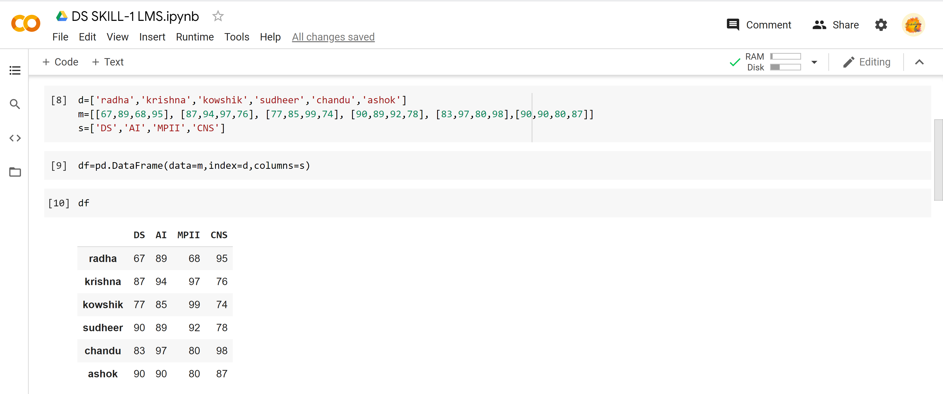

* 3. Add the TS , total columns to the data frame from which TS is the sum of DS,AI,MPII and total is the sum of all subjects?

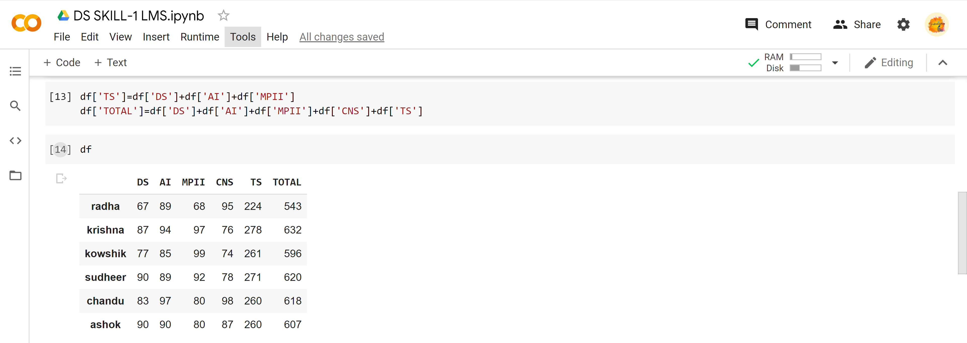

* 4. Display only the marks scored by Name 2 and Name3?

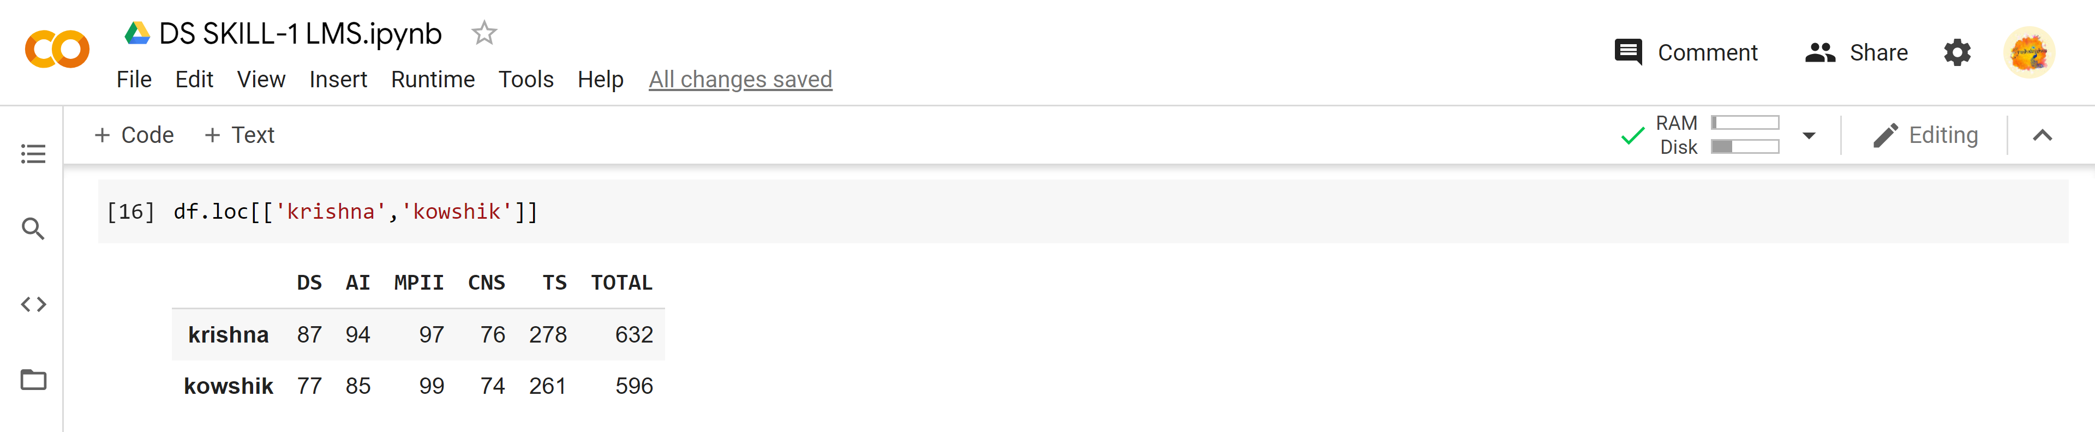

* 5. Display all the students marks who scored 90 + marks in DS?

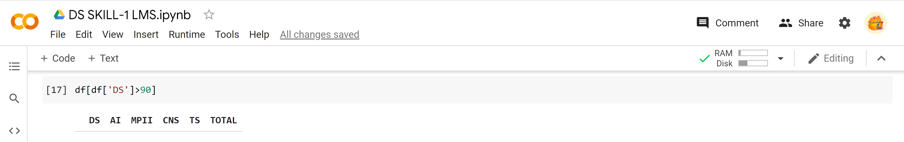

* 6. DS teacher wants to know the total marks achieved by students in DS , Help her by using the sum method in data frame

